**Usability Inquiry Methods**

**For each method describe**

A. What type of study is this? B. What people would be involved in the study?

C. What type of data collected? D. State problems with this method?

**Contextual Inquiry**

This is a proactive field study involving one usability expert and two users. The data collected is mostly qualitative. This data should encompass information about what system the users are currently using and what they like and dislike about it. You should find out about what they already have in place and how you can build on it and make it better. This can’t be done remotely

**Field Observation**

This is done during the testing and deployment stage. This should collect data on user satisfaction and the effectiveness of the system. It should include one usability expert and two users. This data should be qualitative and should encompass how the user actually uses the system. You should try to figure out what the user’s mental model of the system is. This can’t be done remotely, and the user should not know that you are evaluating them.

**Questionnaires**

This can be done at any stage and the questions can be adapted as such. This should collect data on user satisfaction and the effectiveness of the system. This should include one usability expert and two users. Qualitative data can be collected through open questions and quantitative data can be collected from closed questions. These questionaries can sent to user’s and then returned when completed. This can be done remotely and on any system, so there aren’t many problems with this method.

**Interviews**

This can be done at any stage. This should collect data on user satisfaction and the effectiveness of the system. The data will be mostly qualitative. This should include one usability expert and one user. You want to ask questions of the user that get them talking. You don’t want any yes/no questions and you want to remain neutral. You also want to make sure you don’t lead their answers in a certain direction and that you don’t answer your own questions. This can be done remotely and on any system.

**Focus Groups**

This is done during the test and deployment stage. It should include one usability expert and six users. The data will be mostly qualitative. This should collect data on user satisfaction and the effectiveness of the system. This data can be different from interview data as users can communicate to other users the problems they had or the features they liked leading to new questions you might not have thought of before. Clear speaking rules should be defined beforehand. This can be conducted remotely and on any system.

**Logging Actual Use**

This is done during the test and deployment stage. It should include one usability expert and six users. Quantitative data is mostly collected. This should collect data regarding system effectiveness and efficiency and might cover user satisfaction. The system should automatically record this data. This can be done remotely and on any system.

Comp5620/5620/6626

Name: Elizabeth Dayton

Part II:

Find an example of one of the above methods. You can list the first page of an article, the first page of a web, a picture that shows the activity. Print that one page and attach it to this sheet.

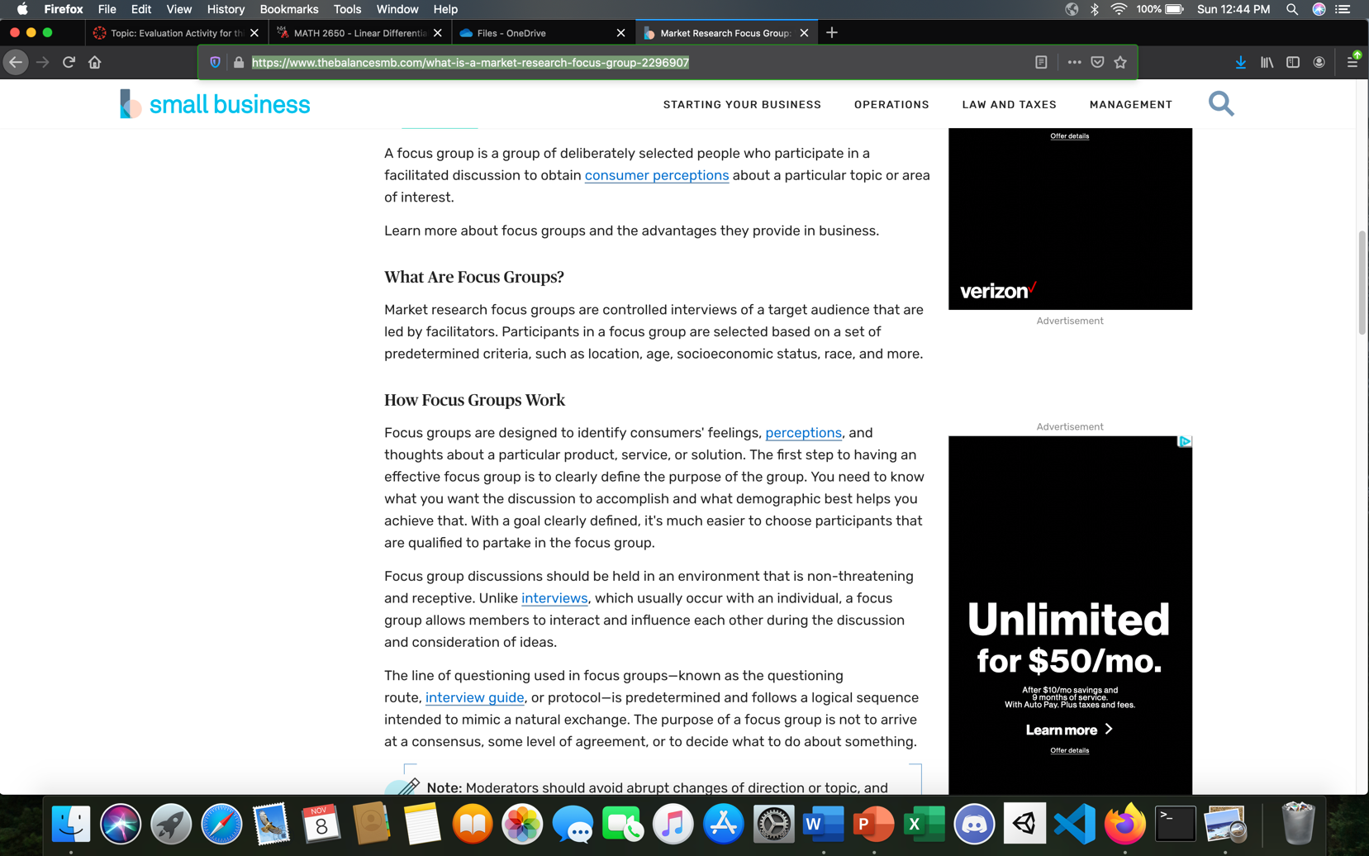<https://www.thebalancesmb.com/what-is-a-market-research-focus-group-2296907>